Cognitive Assessment Using the BAS 3
the British Ability Scales 3 (BAS3), a collection of individual tests used to assess the general thinking and reasoning skills of children aged from 3 to 17 years. The tests are designed to measure abilities that are important for learning, such as problem solving, remembering things, working out how things relate to one another and understanding language.

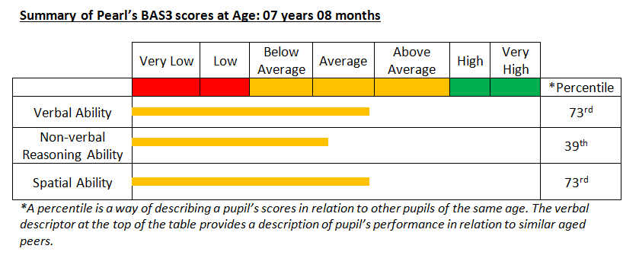

What do the scores mean?
Pearl ranks in the:
- 73rd percentile for Verbal Abilities, meaning she has performed as well as or better than 73% of the national sample. This suggests that her ability to deal with words and use them to think about and solve problems is in the Average range for her age.
- 39th percentile for Non‐verbal reasoning Abilities, meaning she has performed as well as or better than 39% of the national sample. This suggests that her ability to think about and solve problems involving numbers and patterns is in the Average range for her age.
- 73rd percentile for Spatial Abilities, meaning she has performed as well as or better than 73% of the national sample. This suggests that her ability to deal with shapes and space and use them to think about and solve problems is in the Average Range for her age.

Relative cognitive strengths
- Visual short-term memory
- Verbal conceptualisation
- Verbal comprehension
- Verbal expression
- Retrieval of verbal information from long term memory.

Relative cognitive weaknesses
- Use of verbal mediation in solving non-verbal problems.
- Sequential processing of verbal information
- Visual-verbal integration: The test result suggests that her ability to process visual information is an area of relative weakness. Pearl struggles with tasks which require the integration of visual and verbal processing systems to enable her to generate and test a hypothesis. Visual-verbal integration difficulties also impacts the ability to read, as reading involves the same process i.e., Pearl sees the visual stimulus (printed word) – verbally encodes the information (drawing on information stored in her Long-term Memory) – and engage in hypothesis testing to arrive at correct decoded solution.
- Cognitive processing speed: The test results highlighted potential weaknesses in Pearl’s ability to: process information at speed, assimilate information quickly and efficiently, perform tasks fluently and automatically and retrieve information from long-term memory with less effort.

Appendix 1 BAS 3 Information

What the BAS3 RESULTS SHOW
Pearl completed the tests that were most suited to identifying her needs. The tests in the BAS3 combine to produce different types of scores. A summary of these scores and the abilities they test is shown below.
Type of Score | Measured Pearl's ability to…
Verbal Ability | Understand and use spoken words and language.
Non-verbal Reasoning Ability | Works out why numbers, pictures or patterns are linked with others.
Spatial Ability | Remember and make sense of shapes and the way they are arranged
General Conceptual Ability | Use of all three kinds of ability - verbal, spatial, non-verbal reasoning.

How is the BAS3 scored?

The BAS3 scores are presented in percentiles, showing Pearl’s rank when compared with what would be expected for 100 children of the same age. For example, if Pearl ranked in the 55th percentile, it would mean that she scored higher than 55 out of 100 children of the same age.

About two thirds of children will rank between the 16th and 84th percentile, so percentiles help us to decide how typical or unusual Pearl’s score is.

Descriptions of the percentile are provided below.

Percentile | Description
1st – 2nd | Very low
3rd – 8th | Low
9th – 24th | Below Average
25th – 74th | Average
75th – 90th | Above Average
91st – 97th | High
98th – 99th | Very High

Pearl’s scores on the individual tests that make up the BAS3 (Core,) are provided in the following table.

Name of test | Task Pearl was asked to complete.. | Measured Pearl’s ability to... | Percentile | Description of results
Matrices | Shown an incomplete grid of abstract shapes and asked to identify the shape (from a multiple‐choice selection) which completes the pattern. | - Recognise the similarities and relationships between sets of shapes  - Work out and use rules  - Use reasoning and problem solving skills | 54th | Average
Quantitative Reasoning | Shown a series of number patterns and asked to work out the missing number in the series. | - Solve problems using numbers  - Use reasoning and problem solving skills | 31st | Average
Pattern Construction | Shown a 2‐ or 3‐dimensional design using blocks, squares or cubes and asked to copy it within a time limit. | - Accurately observe, analyse and match designs  - Solve a problem under time pressure  - Control hand movements | 58th | Average
Recognition of Designs | Shown one abstract line drawing for a short time; then shown a series of drawings (which includes the original) and asked to identify the original drawing. | - Remember and recognise abstract designs | 79th | Above Average
Verbal Similarities | Three linked items (e.g. banana, apple and orange) are listed out loud; then asked to describe the main link between them (e.g. they are all types of fruit). | - Use expressive language (the ability to say things)  - Identify, group and describe similarities between items  - Use knowledge of words  - Use reasoning skills and express ideas | 66th | Average
Word Definitions | Asked to explain the meaning of individual words. | - Use expressive language (the ability to say things)  - Use knowledge of words.  - Describe the meaning of spoken words. | 79th | Above Average

Skills for learning and executive function
The BRIEF assesses executive function, a collection of processes that are important for guiding, directing and managing cognitive, emotional and behavioural functions during problem solving.

The Table below gives a description of each of the clinical scales on the Behavioural Rating Indices of Executive Function (BRIEF) questionnaire.

Scale | Behavioural Description
Inhibit | Control impulses, stop behaviour at appropriate times
Shift | Move freely from one situation to another, during tasks, activities or lessons.
Emotional control | Manage emotions appropriately.
Initiate | Begin a task or activity independently and generate own ideas
Working memory | Hold information in mind in order to complete a task.
Plan/organise | Anticipate future events, set goals, develop appropriate steps ahead of time to carry out an associated task or action.
Organisation of work space | Keep workspace, play areas and materials in an orderly manner.
Monitor | Check work and assess performance towards a goal.
Behaviour regulation Index | This is the sum of inhibit, shift and emotional control scales and represents the child’s ability to self-regulate in order to complete problem solving.
Metacognition Index | This is the sum of the initiate, working memory, plan/organise, organisation of materials, and monitor scales.
Global Executive Composite | This is a summary score of all eight clinical scores of the brief to indicate overall level of executive function.

Parent and Teacher Ratings from the BRIEF

 | Parent Ratings |  |  | Teacher ratings
Scale/index | T- Score | 90% CI | Range | T-  Score | 90% CI | Range
Inhibit | 60 | 55-65 | Within Normal range | 54 | 50-58 | Within Normal range
Shift | 76 | 68-84 | Elevated | 73 | 67-79 | Elevated
Emotional control | 68 | 62-74 | Elevated | 62 | 57-67 | Within Normal range
Composite behavioural regulation Index | 69 | 65-73 | Elevated | 64 | 60-68 | Within Normal range
Initiate | 71 | 62-80 | Elevated | 75 | 69-81 | Elevated
Working memory | 86 | 80-92 | Elevated | 73 | 69-77 | Elevated
Plan/organise | 82 | 75-89 | Elevated | 73 | 68-78 | Elevated
Organisation of materials | 70 | 63-77 | Elevated | 47 | 43-51
Monitor | 58 | 50-66 | Within Normal range | 68 | 62-74 | Elevated
Metacognition Index | 79 | 75-83 | Elevated | 69 | 67-71 | Elevated
Global Executive Composite | 77 | 74-80 | Elevated | 69 | 67-71 | Elevated

A T-Score of 65 is the threshold for interpretation of a score as ‘elevated’ and therefore any score above this would represent that this is an area of difficulty for the individual. The higher the score the more significant the level of difficulty is experienced by the individual.

